TOGAF® Architecture Vision (Phase A)
Version 0.1, 2026-10-30
CSA Mentoring Unit Enterprise Architecture (A3)
Office of Student Mentoring (Mentoring Unit), Center for Student Affairs, University of Asia and the Pacific
Document Version History
Version Number | Version Date | Revised By | Description | Filename
0.1 | 2026-10-30 | Emmanuel Velasco (with Laufey) | Phase A draft | Architecture Vision.docx

Contents
1. Purpose of this Document 4
1.1 Output and Input 4
2. Problem Description 5
2.1 Stakeholders and their Concerns 5
2.2 List of Issues/Scenarios to be Addressed 6
3. Statement of Architecture 8
4. Summary Views 9
4.1 Value Chain Diagram 9
4.2 Solution Concept Diagram 9
5. Mapped Stakeholders Requirements 11
6. Draft Architecture Definition Document Reference 12
Tracking Information
Project Name | CSA Mentoring Unit Enterprise Architecture (A3)
Prepared By | Emmanuel Velasco | Document Version No. | 0.1
Title | Architecture Vision | Document Version Date | 2026-10-30
Reviewed By | Pending: Aldrin, Deejay Clark Datu | Review Date
Distribution List
From | Date | Phone/Email
Emmanuel Velasco | 2026-10-30

To | Action* | Due Date | Phone//Email
OSM Operations Coordinators | Review
CSA Executive Director (Sponsor) | Approve
Architecture team (Velasco, Aldrin, Datu) | Inform
* Action Types: Approve, Review, Inform, File, Action Required, Attend Meeting, Other (please specify)

Purpose of this Document
The Architecture Vision is created early on in the ADM cycle. It provides a summary of the changes to the enterprise that will accrue from successful deployment of the Target Architecture. The purpose of the Architecture Vision is to provide key stakeholders with a formally agreed outcome. Early agreement on the outcome enables the architects to focus on the detail necessary to validate feasibility. Providing an Architecture Vision also supports stakeholder communication by providing a summary version of the full Architecture Definition.

Output and Input
The TOGAF® Content Framework (see Architecture Deliverables) identifies deliverables that are produced as outputs from executing the Architecture Development Method (ADM) cycle and potentially consumed as inputs at other points in the ADM.
This deliverable is produced, updated, and consumed by the ADM Phases:
Deliverable | Output from… | Input to…
Architecture Vision | A, E | B, C, D, E, F, G, H  Requirements Management

Problem Description
The Office of Student Mentoring (OSM), also called the Mentoring Unit, sits under the Center for Student Affairs (CSA) of the University of Asia and the Pacific (UA&P). UA&P prides itself on its hallmark programs, and the Mentoring Program is one of them. It seeks to develop students not only academically but also socially and holistically. The program could run without OSM, but the unit exists to centralize the program's goals and capabilities across all schools.
Goal: foster holistic (integral) education in line with UA&P's vision.
Objective: see student growth closely.
Change drivers:
- The University President's mandate. From AY 2026-27, students must attend at least three mentoring sessions per semester. Missing this for three consecutive semesters affects enrollment. The rule is non-negotiable. It exists because too few students were taking part, and the President wants to see that the program works and have students understand its benefits.
- Mentoring is a UA&P hallmark. It is unique to the university and is not required by CHED.
- The need for evidence that the program works, aiming at full participation and international recognition.
Scale. The program serves about 1,500 to 1,600 undergraduates through about 180 mentors. School Mentoring Coordinators report that a mentor handles 20 to 30 mentees on average, with individual loads ranging from 2 to 50, and that a coordinator handles 15 to 20 mentors while also serving as a mentor. OSM itself has two staff, who handle session monitoring and mentor training.

Stakeholders and their Concerns
Stakeholder | Role in the program | Concerns
OSM staff | Run the program; compile approved mentors; keep the records; train mentors; email students their assigned mentor | Monitoring sessions; students taking part; actually achieving holistic development; mentor training; faster pairings; new students discovering the program
School Mentoring Coordinators | Make the pairings for their school; also serve as mentors | Every student has a mentor; pairings done on time; students taking part; mentors able to mentor properly; seamless mentor change; new students discovering the program
Mentors | Conduct the mentoring sessions | Holistic development of their students; mentoring well; managing their schedule around mentees
Students (mentees) | Receive mentoring; log their sessions | What they gain from the program; meeting three sessions per semester; logging their sessions
CSA Executive Director (sponsor) | Oversees OSM | OSM policies and programs in line with CSA and ManCom guidelines; the program succeeding
ManCom | Approves programs, policies, and the mentor list | Programs and policies in line with university standards
Registrar | Supplies the list of enrolled students | No direct concern with the program; the list keeps changing as late enrollees come in
IT Office | Creates the Google Forms and sheet connections; OSM owns the tools | No direct concern with the program beyond keeping the forms working
HR and Finance | HR handles connections with external mentors; Finance handles mentor payment | Supporting roles; concerns not raised in the interviews
Guidance Office | Receives referrals from OSM and mentors | Student mental health: problems and concerns that mentoring alone cannot handle

List of Issues/Scenarios to be Addressed
Issues are ranked in the order the team considers most pressing.
# | Issue or scenario | Why it matters
1 | Lack of secure data integrity in the Google Sheets | Pairing and session records are the evidence for the three-session rule, and they are shared by several people. Coordinators have had to rebuild last year's pairings because the final list was not saved.
2 | Students do not take part unless prompted | Participation was low before the policy, which is why the policy exists. New students reach out more often than older ones.
3 | Making the pairings as early as possible | The official list of enrolled students is not complete in the first months of a semester, so new students keep arriving who need mentors. Coordinators also have other duties, and the time taken differs across schools.
4 | Long email chain for mentor-change requests | The student asks OSM, OSM emails the current mentor for approval, then the requested mentor, then the school coordinator, who has the final say. Each change takes several separate emails, and nothing tracks them.
5 | Too few mentors | Mentor loads are uneven and some schools run short. This may reflect the number of professors teaching at the university.
6 | Mentoring schedule conflicts | Some students' schedules do not align with their mentor's, which makes sessions hard to arrange while the rule requires three of them.
7 | Uncertainty in session logging | Students may forget to log their sessions. This is not yet proven, but it would directly affect compliance records and enrollment.
8 | No way to track whether a session met its need | Holistic development varies by student, so a session count alone does not show that mentoring worked.

Statement of Architecture
The scope and approach of this work are set out in the Statement of Architecture Work. In summary:
Target Architecture. All mentoring workflows (pairing, mentor change, mentee contact, session logging, and monitoring) run as one centralized, end-to-end workflow with one shared source of truth for pairings. This replaces today's email chains and separate lists. Pairings are finished on time, within the first month of the semester and ideally before the previous semester ends. School Mentoring Coordinators keep the pairing decision, and OSM can see participation and compliance at any time.
Long-term vision. A program where students attend mentoring freely, without needing a quota or a log, and where every student can say they have developed holistically by their own criteria. The three-session rule is non-negotiable today and needs ongoing evidence, so the target architecture still logs and monitors sessions. The vision guides where the program is heading after that.

Summary Views

Value Chain Diagram
The value chain shows how the unit's capabilities lead from approved mentors to holistic student formation. It uses the seven business capabilities of the Phase B capability map, with Mentoring Sessions shown as the point where value reaches the student.
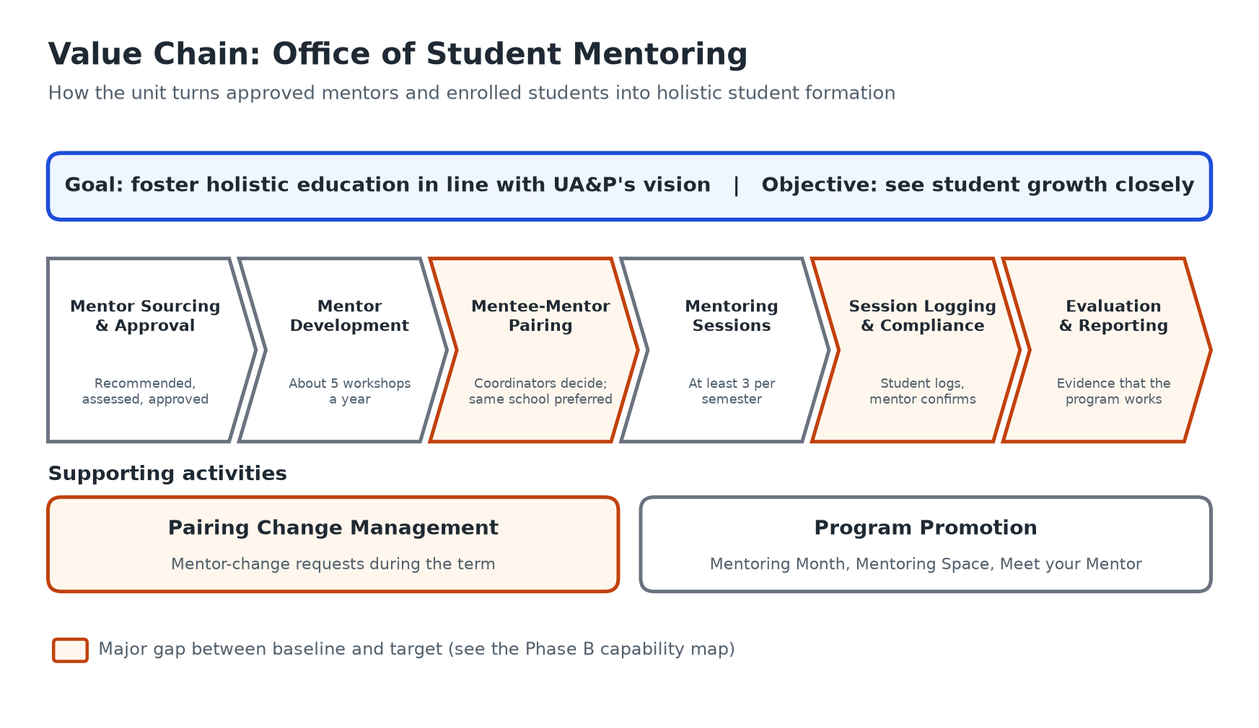
Figure 1. Value Chain Diagram

Solution Concept Diagram
The solution concept places one centralized workflow and a central pairing register between the people who use them. Phase C states what the application must do, and Phase D sets the technology standards. Neither chooses a product.
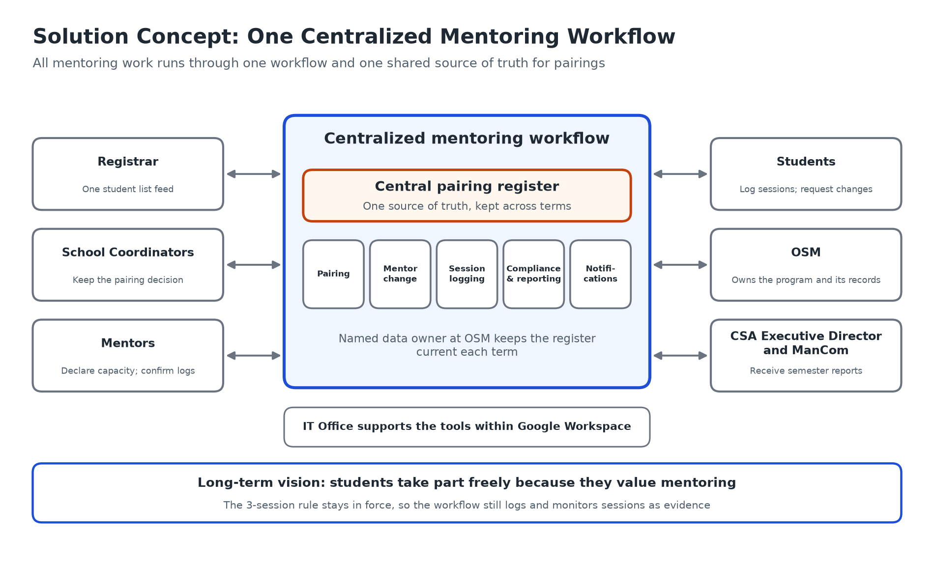
Figure 2. Solution Concept Diagram

Mapped Stakeholders Requirements
Each stakeholder's need is traced to the Phase B success measures (SM) and the Phase C application services (S1 Pairing Register, S2 Mentor Change Requests, S3 Session Logging, S4 Compliance Monitoring and Reporting, S5 Notifications).
Stakeholder | Requirement | Addressed by
OSM staff | One place to see pairings, sessions, and compliance; faster pairing; records kept across terms | S1, S4; SM-01, SM-02, SM-03, SM-06
School Mentoring Coordinators | Keep the pairing decision; see mentor capacity; handle mentor changes without long email chains | S1, S2; SM-02, SM-04, SM-05
Mentors | A clear list of mentees; less email; simple confirmation of sessions | S3, S5; SM-06
Students | Know their mentor early; log sessions easily; request a change simply; see their progress toward three sessions | S2, S3, S5; SM-01, SM-02
CSA Executive Director | Evidence each semester that the program is working | S4; SM-08
ManCom | Reporting on compliance; programs in line with university standards | S4; SM-08
Registrar | One agreed route for the student list, with no extra work | S1; SM-07
IT Office | Tools that stay within what it already supports | Phase D technology standards
HR and Finance | No change to their current roles; approved mentor list remains the shared reference | S1 (reads the approved list)
Guidance Office | Referral path stays open and unchanged | Kept outside the application

Draft Architecture Definition Document Reference
A separate Architecture Definition Document was not produced for this submission, because the team chose only the necessary templates. Its content is held in the Phase B Architecture Requirements Specification and Architecture Roadmap, and in the Phases C and D Architecture Deliverables, which carry the baseline and target architectures and the gap analysis.
Sources: Interview with OSM (2026-09-11); Interview with OSM (2026-09-28); Interview with SSE Mentoring Coordinator (2026-10-16); Interview with SED Mentoring Coordinator (2026-10-20); Phase A inputs from E. Velasco (2026-10-30); Phase B Architecture Requirements Specification and Architecture Roadmap; Phases C and D Architecture Deliverables.

